BODY CHECK - CLINICAL

Individual’s Name________________________________________________________________

Indicate on the chart below all bruises/discolorations, skin breaks, injuries etc.
Describe below as needed, being as specific as possible (measure in cm’s)
If there is more than one area affected, please number them (1, 2, 3 etc.)
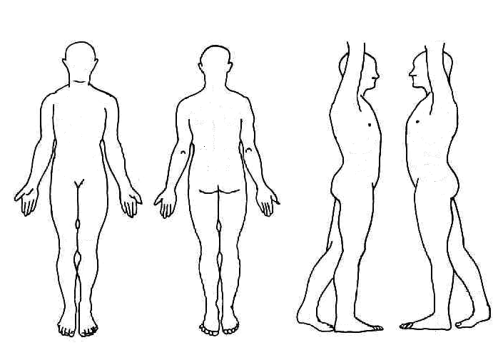

R L L R

FRONT BACK RIGHT SIDE LEFT SIDE

Description: ___________________________________________________________________
________________________________________________________________________________________________________________________________________________________________________________________________________________________________________________________________________________________________________________________

Examiner ______________________________Title__________________ Date ____/____/____

Witness _______________________________Title__________________ Time _______ AM PM

Is this an Incident? ◻ No ◻ Yes (If ☑ YES, attach this form to the Incident Report)

